1. Add candidate – position:
   1. Can not find candidate:

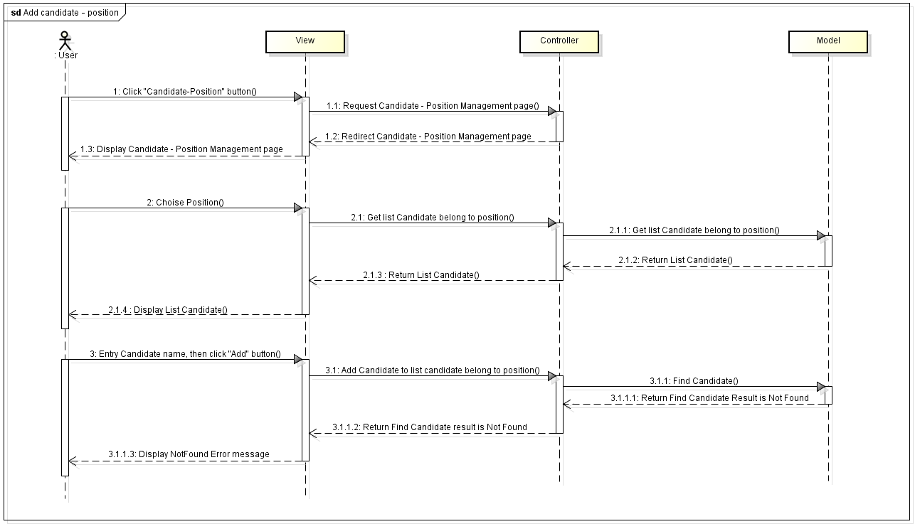

* 1. Can not change position of candidate:

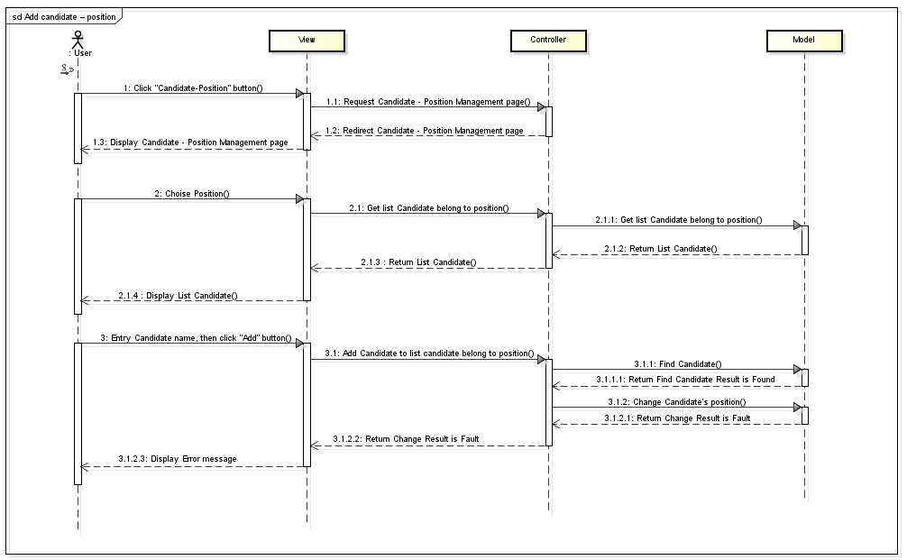

* 1. Success:

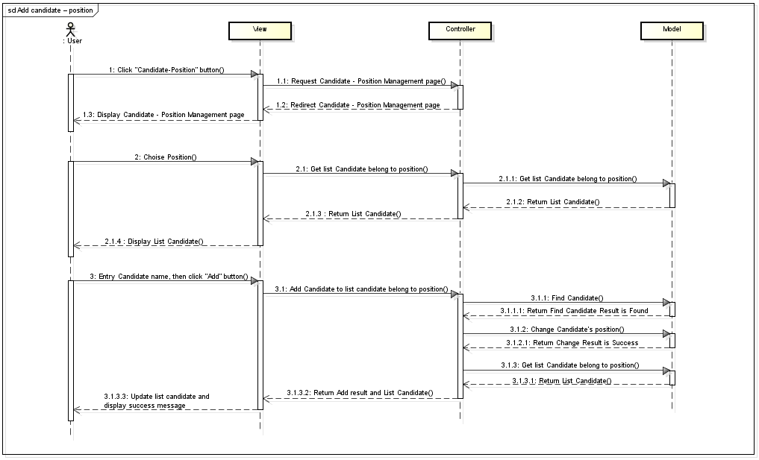

1. Remove candidate – position:
   1. Can not find candidate:

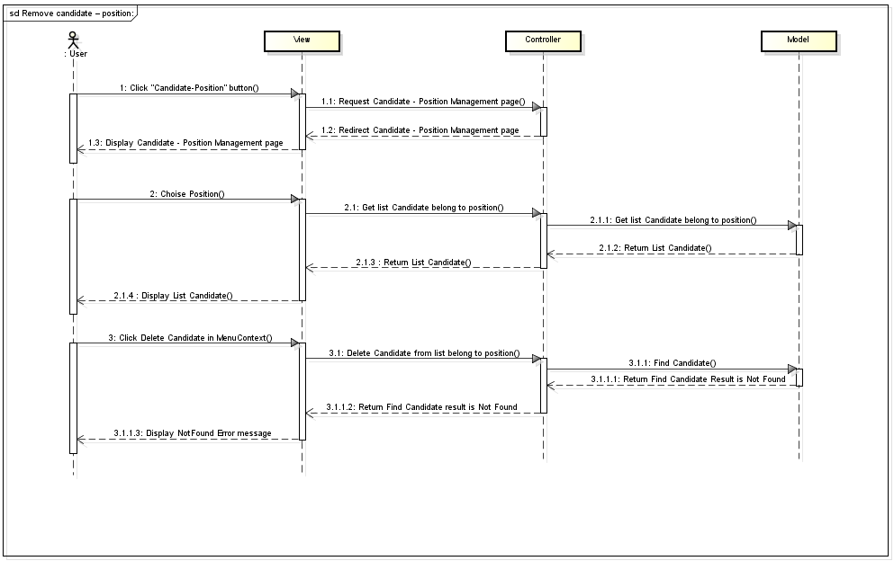

* 1. Can not change position of candidate:

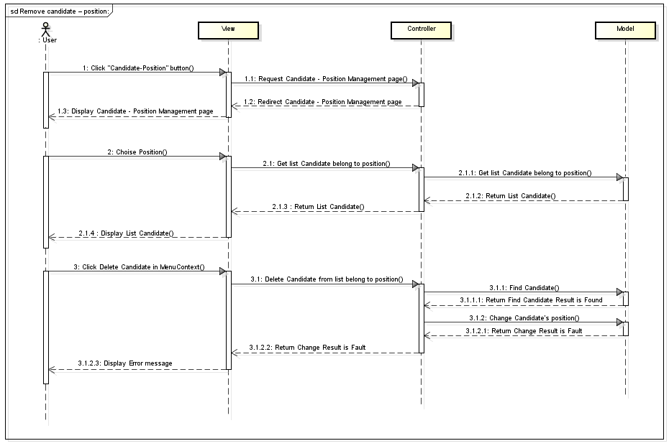

* 1. Success:

